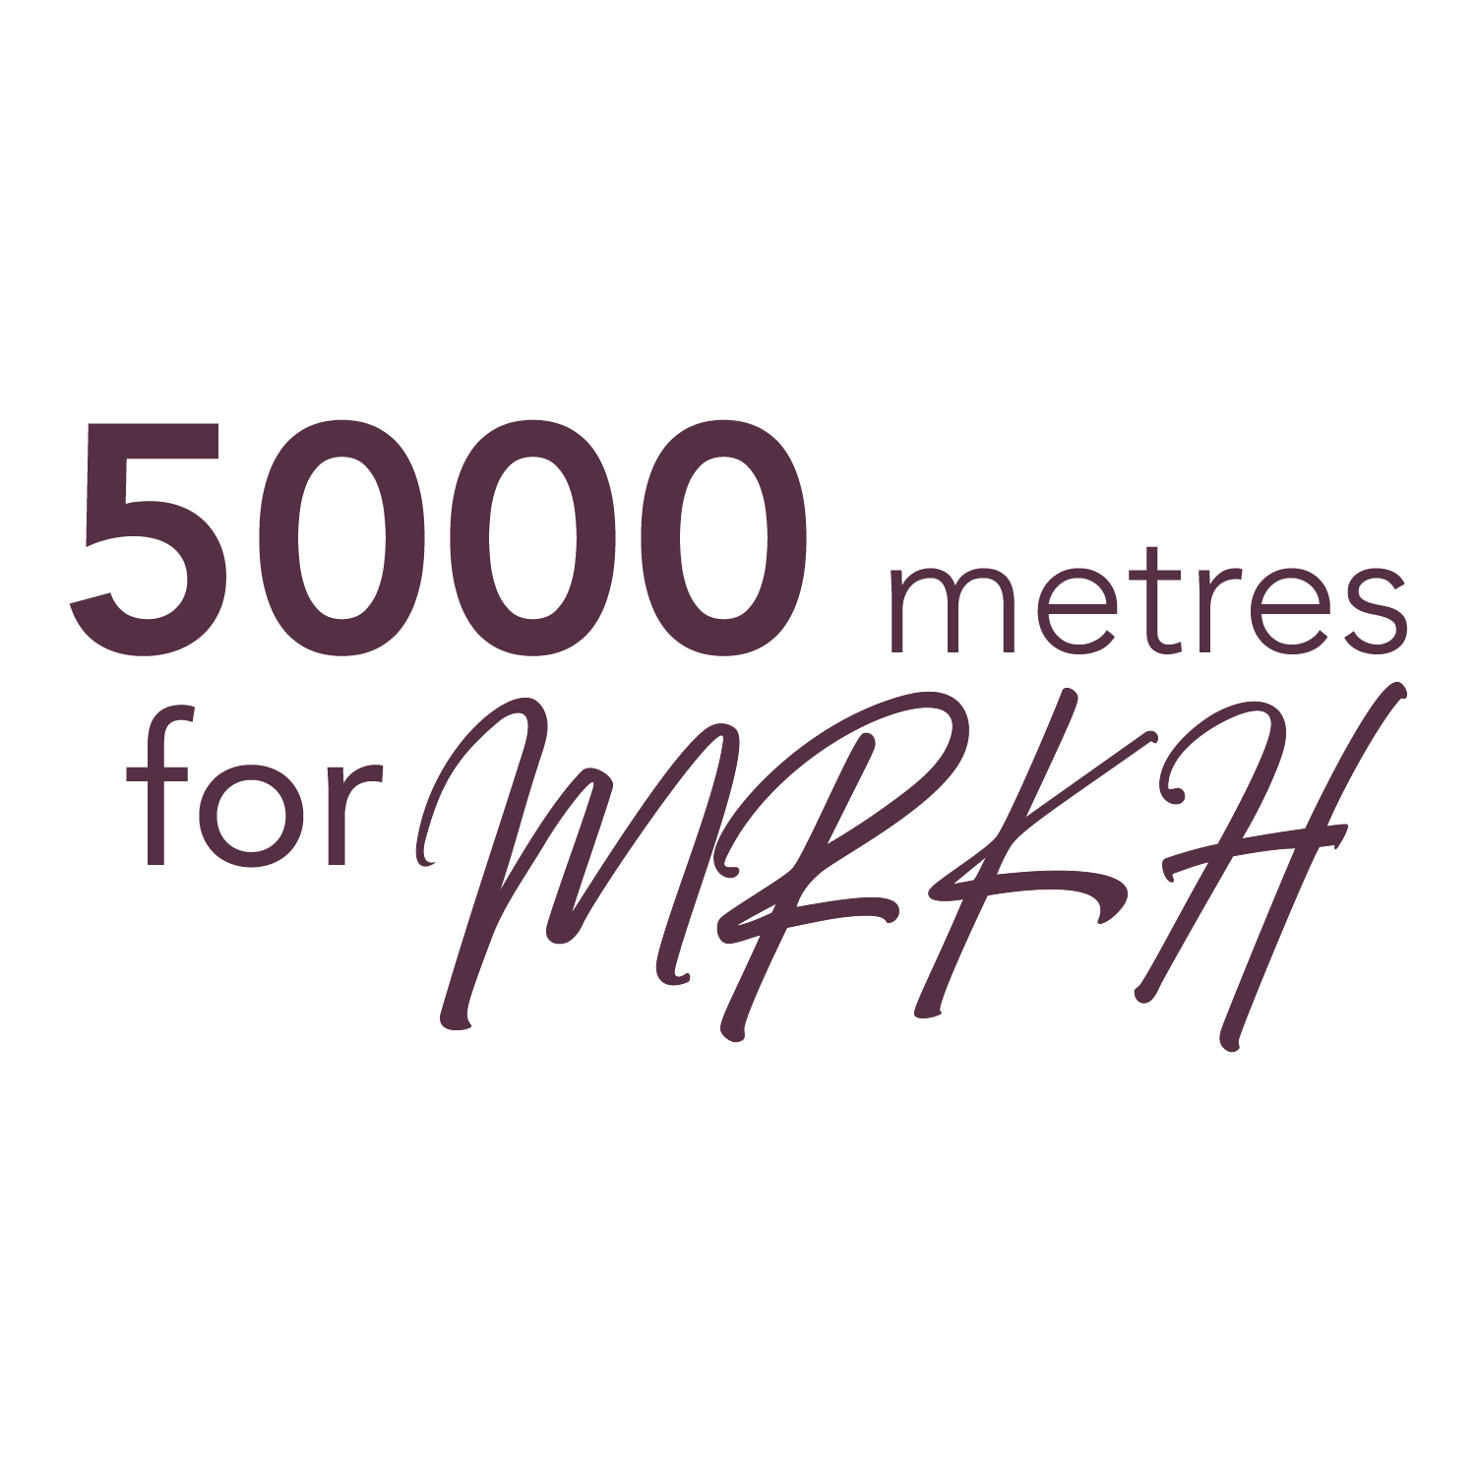

**PLEDGE FORM**

**Name of Participant: ______________________**

On June 11, I will be participating in the 5000 Metres for MRKH (5K) Fundraiser in support of those born with MRKH Syndrome, a congenital condition that affects the development of the reproductive system in approximately 1 in 5000 females. Funds raised will go towards MRKH Canada, the only not-for-profit organization in Canada dedicated to supporting those with MRKH. Our goal is to raise $5000 to go towards the next in-person conference and to help with the start-up costs of becoming an official registered charity. For more info, go to mrkhcanada.ca.

My personal goal is to raise $__________

How we accept donations:

* E-Transfer to info.mrkhcanada@gmail.com with the password “MRKH”
* Cash or cheque mailed to 311-1023 Pembridge Crescent, Kingston, ON, K7P1M8
* Online at mrkhcanada.ca/pledges

|  |  |  |  |
| --- | --- | --- | --- |
| Name of Donator | Pledge Amount | Received (Y) | Method  (Cash, Cheque, PayPal, E-Transfer) |
| 1 |  |  |  |
| 2 |  |  |  |
| 3 |  |  |  |
| 4 |  |  |  |
| 5 |  |  |  |
| 6 |  |  |  |
| 7 |  |  |  |
| 8 |  |  |  |
| 9 |  |  |  |
| 10 |  |  |  |